# **Problem #1 to #5 Solutions**

—-----------------------------------------------------------------------------------------------------------------------

# **Problem 1**

—-----------------------------------

Description Write a program to print your

< the code below>

—---------------------------------------------------------------  
  
#include <iostream>

using namespace std;

void PrintName(string name){

cout<<"\n Your Name Is "<< name<<endl;

}

int main(){

PrintName("Ahmed");

return 0;

}

—----------------------------------------------------------------------------------------------------------------------------

The output:

===============

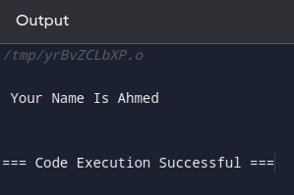

# **Problem 2**

=======================

Description: Write A program To read the name and print it<The Code below>

==================

#include <iostream>

using namespace std;

string ReadName(){

string name;

cout<<"Enter Your Name: ";

getline(cin,name);

return name;

}

void PrintName(string name){

cout<<"\n Your Name Is: "<<name;

}

int main(){

PrintName(ReadName()); // function print name takes the function readname;

return 0;

}

=====================

The output:

============

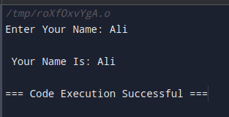

—---------------------------------------------------------------------------

# **Problem 3**

===========================

Description: Write A program to check read the number and check if it odd or even <The code>

—--------------------------------------------------

#include <iostream>

using namespace std;

enum enNumberType {Even = 0, Odd = 1};

int ReadNumber(){

int N = 0;

cout<<"Enter The Number: ";

cin>> N;

return N;

}

enNumberType CheckNumberType(int Number){

int Result = Number % 2; // Number = Number % 2

if(Result == 0)

return enNumberType::Even;

else

return enNumberType::Odd;

}

void PrintNumberType(enNumberType Number){

if(Number == enNumberType::Even)

cout<<"\n The Number Is Even";

else

cout<<"\n The Number Is Odd";

}

int main(){

PrintNumberType(CheckNumberType(ReadNumber()));

return 0;

}

===================================================================

The output:

============

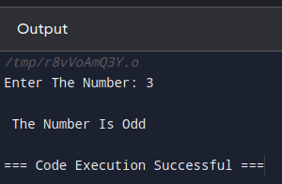

========================================================================

# **Problem 4**

=========================

Description: Write A program to Hire A driver case 1;

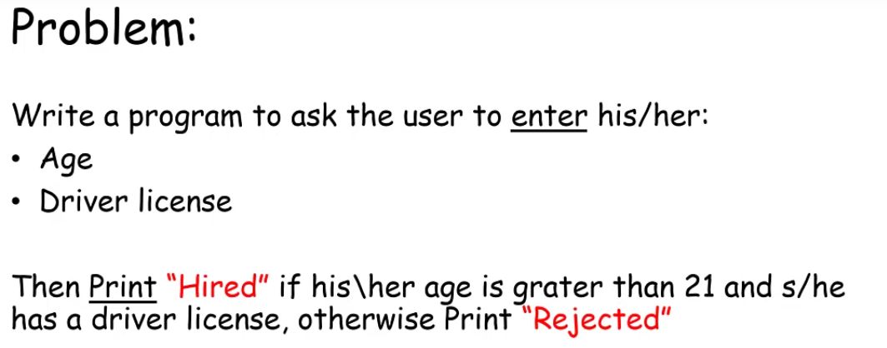

===========================

The code:

=========

#include <iostream>

using namespace std;

struct stInfo{

Short Age;

bool HasAdriverLicense;

};

stInfo ReadInfo(){

stInfo Info;

cout<<"Please Enter Your Age: ";

cin>> Info.Age;

cout<<"\nDo you Have A driver License?: ";

cin>> Info.HasAdriverLicense;

return Info;

}

bool IsAccepted(stInfo Info){

return (Info.Age > 21 && Info.HasAdriverLicense);

}

void PrintResult(stInfo Info){

if(IsAccepted(Info))

cout<<"\n Hired";

else

cout<<"\n Rejected";

}

int main(){

PrintResult(ReadInfo());

return 0;

}

================================

The output:

==============

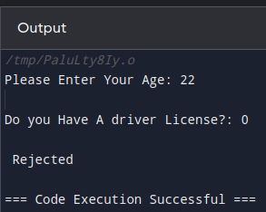

==============================================

# **Problem 5**

============================

Description: Write A program to Hire A driver case 2;

==========================================

If you’ve a recommendation you will hired

The code below;

—----------------------------

#include <iostream>

using namespace std;

struct stInfo{

int Age;

bool HasAdriverLicense;

bool HasRecommendation;

};

stInfo ReadInfo(){

stInfo Info;

cout<<"Please Enter Your Age: ";

cin>> Info.Age;

cout<<"\nDo you Have A driver License?: ";

cin>> Info.HasAdriverLicense;

cout<<"\nDo you Have A Recommendation?: ";

cin>> Info.HasRecommendation;

return Info;

}

bool IsAccepted(stInfo Info){

if(Info.HasRecommendation)

return true;

else

return (Info.Age > 21 && Info.HasAdriverLicense);

}

void PrintResult(stInfo Info){

if(IsAccepted(Info))

cout<<"\n Hired";

else

cout<<"\n Rejected";

}

int main(){

PrintResult(ReadInfo());

return 0;

}

========================================================================

The output:

===========

